**Chapter 1**

**INTRODUCTION**

A Human Resources Information System (HRIS) is a technological solution that is designed to help businesses manage and organize their HR processes more effectively. An HRIS can be a game-changer for organizations looking to streamline their HR functions and automate routine tasks, such as employee record-keeping, payroll processing, benefits administration, and performance evaluation.

The primary purpose of an HRIS is to centralize employee data and make it easier for HR professionals to access and manage that data. This technology solution can help businesses achieve a wide range of benefits, such as increased efficiency, improved accuracy, reduced administrative costs, better compliance, and increased employee satisfaction.

The implementation of an HRIS can also help businesses to stay up to date with the latest trends and best practices in HR management. With the help of an HRIS, businesses can more easily track and analyze employee data, identify areas for improvement, and make data-driven decisions.

**1.1 Literature Survey**

* **Benefits of HRIS**: A significant body of research has shown that HRIS can provide businesses with a wide range of benefits, such as improved efficiency, accuracy, cost-effectiveness, and employee satisfaction.
* **Adoption and implementation**: Many studies have explored the factors that influence the adoption and implementation of HRIS, such as organizational culture, top management support, user involvement, and training and support.
* **Impact on HR practices**: HRIS has been shown to have a significant impact on HR practices, such as recruitment and selection, performance management, training and development, and compensation and benefits.
* **Challenges and limitations**: Despite the benefits of HRIS, researchers have also identified several challenges and limitations, such as data security and privacy concerns, lack of system flexibility, and resistance to change.
* **Future research directions**: Many studies have called for further research on HRIS, such as exploring the impact of HRIS on employee engagement, the role of HRIS in strategic decision-making, and the impact of HRIS on organizational performance.

**1.2 Existing System**

**Workday**: Workday is a cloud based HRIS system that offers features such as human capital management, payroll processing, talent management, and benefits administration.

**SAP Success Factors**: SAP Success Factors is an HRIS system that offers features such as performance and goal management, recruiting and on boarding, learning and development, and compensation management.

**ADP Workforce Now**: ADP Workforce Now is an HRIS system that offers features such as payroll processing, benefits administration, time and attendance management, and employee self-service.

**Oracle HCM Cloud**: Oracle HCM Cloud is a cloud based HRIS system that offers features such as global HR management, workforce planning, talent management, and payroll processing.

**Bamboo HR**: Bamboo HR is an HRIS system that offers features such as applicant tracking, onboarding, employee data management, and performance management.

These systems vary in terms of their pricing, functionality, and deployment options, allowing organizations to choose the one that best fits their needs and budget. Organizations may also opt to build a custom HRIS solution or use open-source HRIS software, depending on their requirements and resources.

**1.3 Proposed System**

* **Employee data management**: The system would allow HR professionals to manage employee data, such as personal information, job history, and performance evaluations, in a centralized database.
* **Payroll processing**: The system would automate payroll processing, including calculations of taxes, deductions, and benefits.
* **Benefits administration**: The system would allow HR professionals to manage employee benefits, such as health insurance and retirement plans, and enable employees to enroll in and manage their benefits online.
* **Performance evaluation**: The system would provide tools for HR professionals to manage employee performance evaluations, track performance goals, and provide feedback.
* **Training and development**: The system would allow HR professionals to manage employee training and development programs and provide employees with access to training materials.
* **Recruitment and onboarding**: The system would provide tools for HR professionals to manage the recruitment process, including applicant tracking and background checks, as well as the onboarding process for new employees.
* **Analytics and reporting**: The system would provide HR professionals with tools to generate reports and analytics on employee data, including turnover rates, performance metrics, and employee engagement.

**Chapter 2**

**ANALYSIS AND FEASIBILITY**

## **2.1 Analysis**

An analysis of a Human Resources Information System (HRIS) involves evaluating its effectiveness in meeting the needs of an organization and determining its impact on HR processes and overall organizational performance. The following are key areas of analysis for an HRIS:

* **Functionality**: The system's features and capabilities should align with the organization's HR needs and goals. For example, if the organization requires robust performance management features, the HRIS should provide tools for setting goals, tracking progress, and providing feedback.
* **Usability**: The system should be user-friendly, intuitive, and easy to navigate. HR professionals and employees should be able to access the information and tools they need quickly and efficiently.
* **Integration**: The HRIS should be able to integrate with other software applications used by the organization, such as accounting and time and attendance systems, to ensure that data is accurate and up to date across systems.
* **Security**: The system should have appropriate access controls and encryption to protect sensitive employee data and prevent unauthorized access or data breaches.
* **Cost-effectiveness**: The HRIS should provide a reasonable return on investment (ROI) by reducing HR costs and improving organizational efficiency and productivity.
* **Impact on HR processes**: The HRIS should improve HR processes by streamlining workflows, reducing manual tasks, and providing real-time access to employee data. The impact of the HRIS on HR processes should be measured and evaluated regularly.
* **Impact on organizational performance**: The HRIS should have a positive impact on organizational performance by improving employee engagement, reducing turnover rates, and enhancing overall productivity.

## **2.2 Feasibility Study**

A feasibility study of a Human Resources Information System (HRIS) is an assessment of its potential to meet the needs of an organization and determine if it is feasible to implement. The following are key areas of a feasibility study for an HRIS:

* **Technical feasibility**: This involves evaluating if the HRIS can be developed and implemented using available technology. This includes assessing if the HRIS can integrate with existing systems and hardware and if he required technical resources are available.
* **Economic feasibility**: This involves evaluating the cost of developing and implementing the HRIS and determining if the benefits justify the investment. This includes assessing the ROI and evaluating the potential for cost savings and increased efficiency.
* **Legal and regulatory feasibility**: This involves evaluating if the HRIS complies with applicable laws and regulations, such as data privacy and security regulations.
* **Operational feasibility**: This involves evaluating if the HRIS is practical and easy to use, and if it aligns with the organization's goals and objectives.
* **Schedule feasibility**: This involves evaluating if the HRIS can be developed and implemented within the organization's timeline and if the required resources are available.
* **Cultural feasibility**: This involves evaluating if the HRIS aligns with the organization's culture and if employees will be willing to adopt it.

Overall, a feasibility study of an HRIS should assess if it is technically, economically, legally, operationally, schedule-wise, and culturally feasible for an organization to develop and implement.

**Chapter 3**

**PROJECT REQUIREMENTS**

**3.1 About Proposed Project**

A Human Resource Information System (HRIS) is a software solution that is designed to streamline and automate the management of human resource functions within an organization. The system can be used to manage employee data, track performance, monitor attendance, and manage benefits and compensation, among other functions.

Here are some proposed features for a HRIS project:

* **Employee Information Management**: The system should have the ability to store and manage employee data such as personal information, contact details, job title, and department.
* **Recruitment Management**: The system should allow HR personnel to post job openings, receive resumes, and manage the recruitment process.
* **Performance Management**: The system should provide tools to track employee performance, set goals, and manage performance reviews.
* **Time and Attendance Management**: The system should allow employees to log their attendance, track their hours worked, and request time off.
* **Benefits and Compensation Management**: The system should provide a platform for managing employee benefits, such as health insurance and retirement plans. It should also have the ability to manage compensation, including salary, bonuses, and raises.
* **Training and Development Management**: The system should allow HR personnel to track employee training and development, as well as provide access to training resources.
* **Reporting and Analytics**: The system should generate reports and provide analytics to help HR personnel make informed decisions about workforce management.
* **Mobile Access**: The system should have a mobile app that allows employees to access their information and perform tasks on-the-go.
* **Integration with Other Systems**: The system should be able to integrate with other HR-related systems, such as payroll and accounting software.
* **Security and Compliance**: The system should have robust security features to protect employee data, as well as comply with data privacy regulations.

**3.2Area of Implementation**

**Organizations**:

The organization of a Human Resource Information System (HRIS) is crucial to its effective use and functionality. Here are some key steps to consider when organizing an HRIS:

* **Define the scope and objectives**: Determine what you want the HRIS to achieve and what functionalities it should have. This includes identifying the features and modules required to meet the organization's HR needs.
* **Assess data requirements**: Identify the data that needs to be collected and stored in the HRIS. This includes employee information, job data, performance metrics, attendance records, benefits, and compensation data.
* **Design the system architecture**: Design the structure and organization of the HRIS. This includes defining the database structure, user interface, data input and output methods, and security protocols.
* **Define user roles and permissions**: Define user roles and permissions to determine who has access to specific data and functionality within the HRIS. This helps to protect sensitive data and maintain data security.
* **Develop data entry protocols**: Develop protocols for data entry, storage, and retrieval. This includes establishing standards for data formats, data validation rules, and data backup and recovery procedures.
* **Test and implement the system**: Conduct thorough testing of the HRIS before implementing it. This includes testing the system's functionality, user interface, data input and output, and security features. Once the system is tested, it can be implemented and rolled out to the organization.
* **Provide training and support**: Provide training and support to ensure that users understand how to use the HRIS. This includes providing training manuals, user guides, and helpdesk support to assist users in case they have any issues.

Overall, the successful organization of an HRIS requires careful planning and attention to detail. By following these steps, organizations can develop a system that meets their HR needs and supports their workforce management goals.

**3.3 System Requirements and Specification (SRS)**

**3.3.1 Functional Requirements**

Functional requirements are the capabilities, features, and tasks that a Human Resource Information System (HRIS) should be able to perform. Here are some key functional requirements of an HRIS:

* **Employee data management**: The HRIS should be able to store and manage employee data, including personal information, employment history, and performance evaluations.
* **Time and attendance management**: The HRIS should be able to manage employee time and attendance, including tracking hours worked, managing overtime, and managing time off requests.
* **Recruitment management**: The HRIS should provide tools to manage the recruitment process, including job postings, resume screening, applicant tracking, and interview scheduling.
* **Performance management**: The HRIS should provide tools to manage employee performance, including goal setting, performance evaluations, and performance improvement plans.
* **Benefits and compensation management**: The HRIS should manage employee benefits and compensation, including managing insurance coverage, managing retirement plans, and processing payroll.
* **Training and development management**: The HRIS should manage employee training and development, including tracking training completion, identifying skills gaps, and recommending training programs.
* **Reporting and analytics**: The HRIS should provide reporting and analytics capabilities to help HR personnel make data-driven decisions about workforce management.
* **Compliance management**: The HRIS should help manage compliance with labor laws, including tracking compliance with regulations such as the Family and Medical Leave Act (FMLA) and the Affordable Care Act (ACA).
* **Mobile access**: The HRIS should provide mobile access, allowing employees to view their information, make time off requests, and complete other tasks using a mobile device.
* **Integration with other systems**: The HRIS should be able to integrate with other HR-related systems, such as payroll and accounting software.

**3.3.2 System Requirement:**

System requirements are the technical specifications that a Human Resource Information System (HRIS) must meet to function effectively. Here are some key system requirements for an HRIS:

* **Platform and operating system**: The HRIS should be compatible with the platform and operating system used by the organization. This may include support for Windows, MacOS, or Linux.
* **Database management system**: The HRIS should support the database management system used by the organization. This may include support for SQL Server, Oracle, or MySQL.
* **Hardware and infrastructure**: The HRIS should be able to run on the organization's hardware infrastructure, including servers, storage devices, and network infrastructure.
* **Web browser compatibility**: The HRIS should be compatible with the web browser used by the organization. This may include support for Chrome, Firefox, or Internet Explorer.
* **Security features**: The HRIS should have robust security features to protect employee data, including support for encryption, firewalls, and intrusion detection systems.
* **Scalability**: The HRIS should be scalable to support the growth of the organization's workforce, including the ability to add new users and data storage capacity as needed.
* **Backup and recovery**: The HRIS should support regular backups of data to ensure data is protected in the event of system failures or disasters.
* **Integration with other systems**: The HRIS should be able to integrate with other HR-related systems, such as payroll and accounting software, and should support common data exchange protocols, such as REST or SOAP.
* **Mobile accessibility**: The HRIS should be accessible on mobile devices and should support mobile-specific features, such as responsive design, mobile notifications, and mobile-specific authentication methods.
* **Compliance and regulation**: The HRIS should be designed to comply with relevant labor laws and regulations, such as the Fair Labor Standards Act (FLSA) and the Americans with Disabilities Act (ADA).

**3.4 Hardware Requirements**

**3.4.1 Project Development:**

|  |  |  |
| --- | --- | --- |
| **Sr. No.** | **Hardware** | **Description** |
| **1** | Processor | Intel core i3 or higher |
| **2** | Hard Disk | 5GB or higher |
| **3** | Memory | 1GB RAM or higher |

**3.5 Software Requirements**

**3.5.1 Project Development**

|  |  |  |
| --- | --- | --- |
| **Sr. No.** | **Software** | **Description** |
| **1** | Operating System | Windows XP, Windows 7 or higher |
| **2** | Tools | VS Code , Notepad++, XAMPP |
| **3** | Database Connectivity | SQL , PHP m admin |
| **4** | Technologies used | HTML ,CSS, JavaScript BOOT, PHP |

* 1. **Advantages of Project**
* **Streamlined HR processes**: HRIS can automate many manual HR processes, such as time and attendance tracking, employee record-keeping, and payroll processing, leading to time and cost savings, and reducing the likelihood of errors.
* **Improved accuracy and reliability**: An HRIS can help ensure that employee data is accurate and up to date, reducing the risk of errors, and improving the reliability of HR-related data.
* **Enhanced workforce analytics**: HRIS provides HR professionals with access to data and analytics that can help inform decision-making around workforce planning, performance management, and employee development.
* **Improved employee engagement**: HRIS can provide employees with self-service tools, such as online benefits enrollment, performance reviews, and time-off requests, leading to greater engagement and satisfaction.
* **Increased compliance**: HRIS can help ensure compliance with labor laws and regulations, by automating processes such as time tracking, record-keeping, and reporting.
* **Improved security**: HRIS can provide robust security features to protect employee data, including encryption, firewalls, and intrusion detection systems.
* **Cost savings**: HRIS can lead to cost savings by reducing the need for manual HR processes and reducing errors, leading to lower HR-related costs overall.
  1. **Limitations and Constraints of Project**
* **Dependence on technology**: HRIS requires a significant investment in technology, infrastructure, and technical support, which may limit accessibility for some organizations or employees.
* **Limited customization**: Some HRIS systems may have limited flexibility in terms of customization and may not meet the unique needs of certain organizations or HR departments.
* **Data quality**: The accuracy and reliability of HRIS data depend on the quality of the data entered the system. Poor data quality can lead to inaccurate insights and decisions.
* **Cost**: HRIS implementation and maintenance costs can be high, especially for small and mid-sized organizations. Additionally, training and support costs should also be considered.
* **Security concerns**: As HRIS systems store sensitive employee data, there is a risk of data breaches and cyber-attacks. Organizations need to invest in robust security measures to mitigate this risk.
* **Need for ongoing maintenance**: HRIS requires ongoing maintenance to ensure data accuracy, software updates, and bug fixes. Failure to keep the system updated can lead to performance issues and security vulnerabilities.
* **User adoption**: HRIS requires user adoption from all levels of the organization, including HR personnel and employees. If the system is not user-friendly, it may be challenging to get full user adoption.

**Chapter 4**

**PROJECT DESIGN AND IMPLEMENTATION**

**4.1 Design Concept**

**Define QA processes and criteria**: The first step in implementing a QA system for an HRIS is to define the processes and criteria for quality assurance. This can involve creating a QA plan, outlining the goals and objectives of the QA system, and defining the metrics for measuring the quality of the HRIS.

**Identify the scope of the QA system**: Determine the scope of the QA system by identifying the parts of the HRIS that will be tested and evaluated, such as the user interface, database, and data security.

**Develop test plans and test cases**: Develop test plans and test cases to evaluate the HRIS against the criteria defined in step 1. This involves identifying different scenarios and use cases for testing, defining expected results, and documenting the testing process.

**Execute tests**: Conduct testing on the HRIS using the test plans and test cases developed in step 3. This can involve manual testing, automated testing, or a combination of both.

**Report defects and issues**: Any defects or issues identified during the testing process should be reported and documented. This can involve creating a defect report that includes the details of the issue, the steps to reproduce it, and its impact on the HRIS.

**Review and analyze results**: Review and analyze the results of the testing to determine if the HRIS meets the defined quality criteria. This can involve reviewing test logs, defect reports, and other relevant documentation to identify areas that need improvement.

**Implement improvements**: Based on the results of the QA testing, implement improvements to the HRIS. This can involve fixing defects, optimizing performance, and enhancing the user experience.

**Repeat the process**: Continuously repeat the QA process to ensure that the HRIS meets the defined quality criteria and to identify any new issues that may arise. This can involve updating the test plans and test cases, as well as refining the QA processes and criteria as needed.

## 

Fig 4.1.1: QA System flow

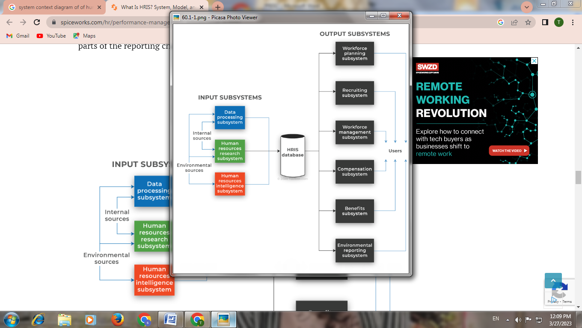

**Fig. 4.1.2: System Context Diagram**

This model enumerates the basic functioning of an HRIS – from input to output. Both environmental and internal sources provide data for the input subsystems, which are then interpreted into information and used in recruiting, workforce planning, workforce/talent management, compensation, benefits, and for various parts of the reporting channel.

**4.2 Block Diagram, Flow Chart**

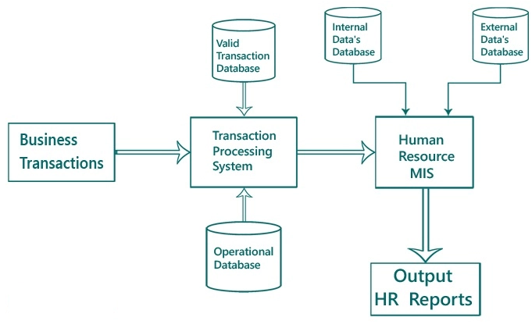

**Fig. 4.2.1.1: Block Diagram**

An information system that is specially designed to automate human resource activities in an organization is known as **Human Resource MIS**. This system is mainly concerned with all activities related to the organization's staff and future employees.

The information system for Human Resource Management can be viewed as a way for large and small organizations to take care of a variety of operations, including human resources, accounting, management, and payroll, using MIS application software. A human resource management information system makes it possible for an organization to more efficiently plan its strategic HR planning, track and monitor them without allocating too many resources.

In most cases, when it comes to making HR decisions, a human resource management information system would also contribute to improved organizational effectiveness. The quality of the decisions taken should also increase and, as a consequence, the efficiency of both employees and executives should increase and become more efficient.

In a **Human Resource MIS**, some of the typical subsystems include design and engineering, planning of production, inventory management, process control, and quality control.

**4.2.4 Flow Chart:-**

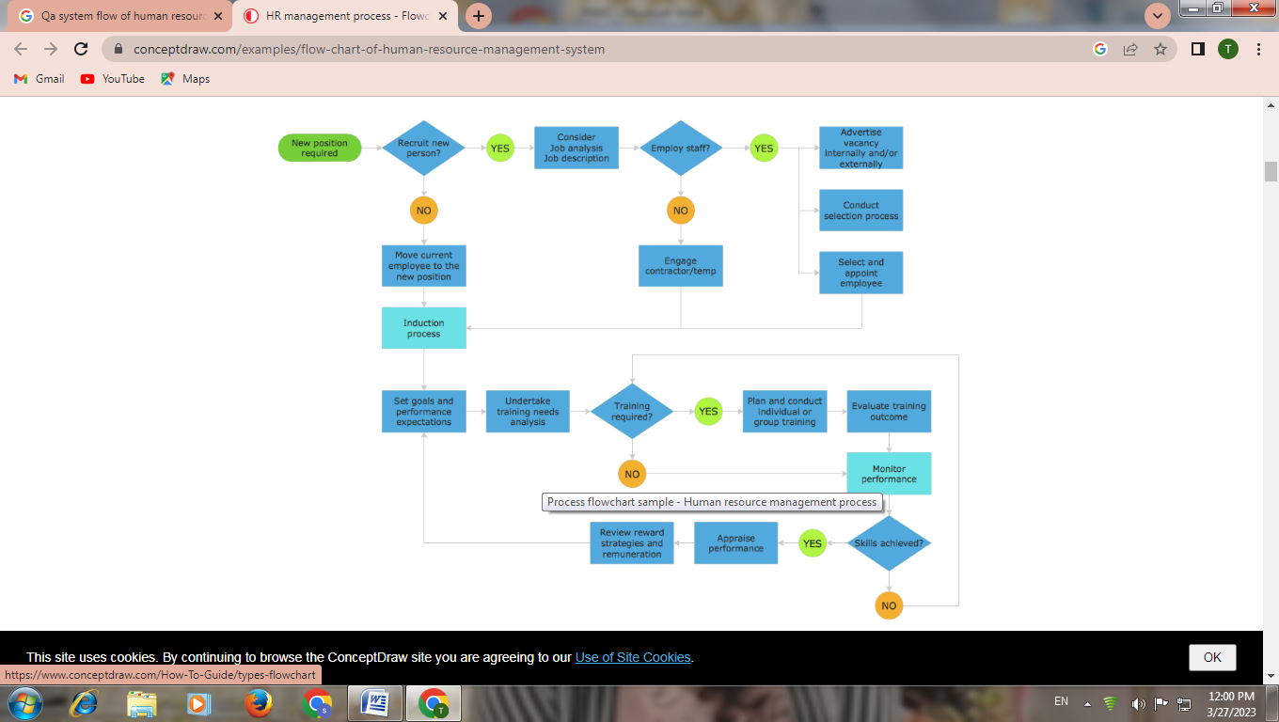

**Fig. 4.2.3.1 : Flow chart of the system**

**4.3 Used Technology**

HTML, CSS, JavaScript, and PHP are commonly used technologies for developing web applications. Each technology serves a specific purpose in the development of an HRIS.

• **HTML (Hypertext Markup Language):**

it is used for creating the structure and content of web pages. In an HRIS, HTML is used to define the layout and structure of the HRIS user interface, such as the forms for collecting employee data, tables for displaying data, and buttons for performing actions.

• **CSS (Cascading Style Sheets):**

It is used to define the presentation and layout of web pages. In an HRIS, CSS is used to style the user interface, such as the colors, fonts, and sizes of text, and the positioning of elements on the page.

• **JavaScript:**

It is used to add interactivity and dynamic behavior to web pages. In an HRIS, JavaScript is used to perform actions when users interact with the HRIS, such as validating input data, displaying pop-up windows, and making asynchronous requests to the server.

• **PHP (Hypertext Pre-processor):**

It is a server-side scripting language used to manage the logic and processing of web applications. In an HRIS, PHP is used to handle user authentication, retrieve and store data in a database, and process user inputs.

Overall, HTML, CSS, JavaScript, and PHP are used in combination to create a robust and functional HRIS that provides an intuitive and user-friendly experience for HR staff and employees.

HTML, CSS, and JavaScript are the three core technologies used in web development to create the frontend of a website or web application. Here are some reasons why we have used them as a front-end:

HTML is the markup language used to structure content on the web. It provides the foundation for the website's structure and defines the layout of the content.

CSS is used to style the HTML content, making it visually appealing to users. CSS allows developers to customize the look and feel of the website, including colours, fonts, and spacing.

JavaScript is a powerful scripting language that is used to add interactivity and dynamic functionality to web pages. It allows developers to create dynamic effects, animations, and interactive features such as forms, pop-ups, and sliders.

Together, HTML, CSS, and JavaScript provide the building blocks for creating dynamic, interactive, and visually appealing web pages and web applications. They are the standard technologies used in frontend

development, and they provide developers with a powerful set of tools to create modern, responsive, and user-friendly web experiences.

Here are some additional reasons why HTML, CSS, and JavaScript are used for frontend development:

**Cross-Platform Compatibility:**

Websites and web applications developed using HTML, CSS, and JavaScript can be accessed on different devices and platforms, including desktops, laptops, tablets, and smartphones, making them more accessible to a wider audience.

**Ease of Use:**

HTML, CSS, and JavaScript are relatively easy to learn and use, and there are plenty of resources available for beginners. The syntax for each language is straightforward, and there are many tools available to help with development.

**Flexibility:**

HTML, CSS, and JavaScript are highly flexible, allowing developers to create a wide range of designs and functionalities. Developers can use CSS to style the website, create animations, and add visual effects, while JavaScript can be used to create dynamic functionality, handle user events, and interact with APIs.

**Compatibility with Other Technologies:**

HTML, CSS, and JavaScript are compatible with a wide range of other technologies, including backend languages, databases, and frameworks. This makes it easier to integrate the frontend with the backend of a website or web application.

**Community Support:**

HTML, CSS, and JavaScript have large and active communities of developers, which means that there are plenty of resources available for troubleshooting and learning. There are also many open-source libraries and frameworks available, making it easier to create complex web applications.

Together, HTML, CSS, and JavaScript provide the building blocks for creating a modern and responsive web page. They allow developers to create a visually appealing and interactive user interface that is easy to navigate and provides users with the information and functionality they need. By using these technologies in a project diagram, developers can ensure that they have a clear understanding of how the frontend of the application will be structured and how the different components will interact with each other.

PHP is a server-side scripting language that is widely used for web development. It is particularly well-suited for building web applications that require server-side processing of data and user inputs, such as an HRIS.

Here are some of the reasons why PHP is commonly used in the development of HRIS:

**Server-side processing:**

PHP is a server-side scripting language, which means that it runs on the server rather than on the client's browser. This allows for server-side processing of data and user inputs, such as retrieving and storing data in a database, processing form submissions, and managing user authentication.

**Integration with databases:**

PHP has built-in support for many popular databases, such as MySQL, PostgreSQL, and Oracle. This makes it easy to integrate an HRIS with a database to store and manage employee data.

**Open-source and widely adopted:**

PHP is an open-source language, which means that it is free to use and has a large community of developers who contribute to its development and support. This has led to a wide adoption of PHP in web development, and many HRIS systems are built using PHP.

**Extensible and customizable:**

PHP is a flexible and extensible language that can be customized to suit the specific needs of an HRIS. There are many PHP libraries and frameworks available that provide additional functionality and make it easier to build complex applications.

**Chapter 5**

**CODE & RESULTS**

**5.1 Code**

**Index.php**

<!DOCTYPE html>

<html lang="en">

<?php

session_start();

include('admin/db_connect.php');

ob_start();

$query = $conn->query("SELECT * FROM system_settings limit 1")->fetch_array();

foreach ($query as $key => $value) {

if(!is_numeric($key))

$_SESSION['setting_'.$key] = $value;

}

ob_end_flush();

include('header.php');

?>

<style>

header.masthead {

background: url("http://localhost/HRIS/assets/img/i1.jpg");

background-repeat: no-repeat;

background-size: cover;

}

</style>

<body id="page-top">

<!-- Navigation-->

<div class="toast" id="alert_toast" role="alert" aria-live="assertive" aria-atomic="true">

<div class="toast-body text-white">

</div>

</div>

<nav class="navbar navbar-expand-lg navbar-light fixed-top py-3" id="mainNav">

<div class="container">

<a class="navbar-brand js-scroll-trigger" href="./"></a>

<button class="navbar-toggler navbar-toggler-right" type="button" data-toggle="collapse" data-target="#navbarResponsive" aria-controls="navbarResponsive" aria-expanded="false" aria-label="Toggle navigation"><span class="navbar-toggler-icon"></span></button>

<div class="collapse navbar-collapse" id="navbarResponsive">

<ul class="navbar-nav ml-auto my-2 my-lg-0">

<li class="nav-item"><a class="nav-link js-scroll-trigger" href="index.php?page=home">Home</a></li>

<li class="nav-item"><a class="nav-link js-scroll-trigger" href="index.php?page=about">About</a></li>

</ul>

</div>

</div>

</nav>

<?php

$page = isset($_GET['page']) ?$_GET['page'] : "home";

include $page.'.php';

?>

<div class="modal fade" id="confirm_modal" role='dialog'>

<div class="modal-dialog modal-md" role="document">

<div class="modal-content">

<div class="modal-header">

<h5 class="modal-title">Confirmation</h5>

</div>

<div class="modal-body">

<div id="delete_content"></div>

</div>

<div class="modal-footer">

<button type="button" class="btn btn-primary" id='confirm' onclick="">Continue</button>

<button type="button" class="btn btn-secondary" data-dismiss="modal">Close</button>

</div>

</div>

</div>

</div>

<div class="modal fade" id="uni_modal" role='dialog'>

<div class="modal-dialog modal-md" role="document">

<div class="modal-content">

<div class="modal-header">

<h5 class="modal-title"></h5>

</div>

<div class="modal-body">

</div>

<div class="modal-footer">

<button type="button" class="btn btn-primary" id='submit' onclick="$('#uni_modal form').submit()">Save</button>

<button type="button" class="btn btn-secondary" data-dismiss="modal">Cancel</button>

</div>

</div>

</div>

</div>

<div class="modal fade" id="uni_modal_right" role='dialog'>

<div class="modal-dialog modal-full-height modal-md" role="document">

<div class="modal-content">

<div class="modal-header">

<h5 class="modal-title"></h5>

<button type="button" class="close" data-dismiss="modal" aria-label="Close">

<span class="fa fa-arrow-righ t"></span>

</button>

</div>

<div class="modal-body">

</div>

</div>

</div>

</div>

<div id="preloader"></div>

<footer class="bg-light py-5">

<div class="container">

<div class="row justify-content-center">

<div class="col-lg-8 text-center">

<h2 class="mt-0">Contact us</h2>

<hr class="divider my-4" />

</div>

</div>

<div class="row">

<div class="col-lg-4 ml-auto text-center mb-5 mb-lg-0">

<i class="fas fa-phone fa-3x mb-3 text-muted"></i>

<div>+91 9423532751</div>

</div>

<div class="col-lg-4 mr-auto text-center">

<i class="fas fa-envelope fa-3x mb-3 text-muted"></i>

<!-- Make sure to change the email address in BOTH the anchor text and the link target below!-->

<a class="d-block" href="mailto:ashu989052@gmail.com"</a> </a>

</div>

</div>

</div>

<br>

<div class="container"><div class="small text-center text-muted">Copyright ©2023 All rights reserved This is developed by Syyad Adnanahemad, Ashutosh Kalyankar & Kalp Desai </div>

</footer>

<?php include('footer.php') ?>

</body>

<?php $conn->close() ?>

</html>

**Submit_application.php**

<?php include 'admin/db_connect.php' ?>

<?php

$qry = $conn->query("SELECT * FROM vacancy where id=".$_GET['id'])->fetch_array();

foreach($qry as $k =>$v){

$$k = $v;

}

?>

<div class="container-fluid">

<form id="manage-application">

<input type="hidden" name="id" value="">

<input type="hidden" name="position_id" value="<?php echo $_GET['id'] ?>">

<div class="col-md-12">

<div class="row">

<h3>Application Form for <?php echo $position ?></h3>

</div>

<hr>

<div class="row form-group">

<div class="col-md-4">

<label for="" class="control-label">Last Name</label>

<input type="text" class="form-control" name="lastname" required="">

</div>

<div class="col-md-4">

<label for="" class="control-label">First Name</label>

<input type="text" class="form-control" name="firstname" required="">

</div>

<div class="col-md-4">

<label for="" class="control-label">Middle Name</label>

<input type="text" class="form-control" name="middlename" required="">

</div>

</div>

<div class="row form-group">

<div class="col-md-4">

<label for="" class="control-label">Gender</label>

<select name="gender" id="" class="custom-select browser-default">

<option>Male</option>

<option>Female</option>

</select>

</div>

<div class="col-md-4">

<label for="" class="control-label">Email</label>

<input type="email" class="form-control" name="email" required="">

</div>

<div class="col-md-4">

<label for="" class="control-label">Contact</label>

<input type="text" class="form-control" name="contact" required="">

</div>

</div>

<div class="row form-group">

<div class="col-md-7">

<label for="" class="control-label">Address</label>

<textarea name="address" id="" cols="30" rows="3" required class="form-control"></textarea>

</div>

</div>

<div class="row form-group">

<div class="col-md-7">

<label for="" class="control-label">Cover Letter</label>

<textarea name="cover_letter" id="" cols="30" rows="3" placeholder="(Optional)" class="form-control"></textarea>

</div>

</div>

<div class="row form-group">

<div class="input-group col-md-4 mb-3">

<div class="input-group-prepend">

<span class="input-group-text" id="">Resume</span>

</div>

<div class="custom-file">

<input type="file" class="custom-file-input" id="resume" onchange="displayfname(this,$(this))" name="resume" accept="application/msword,text/plain, application/pdf">

<label class="custom-file-label" for="resume">Choose file</label>

</div>

</div>

</div>

</div>

</form>

</div>

<script>

function displayfname(input,_this) {

if (input.files && input.files[0]) {

var reader = new FileReader();

reader.onload = function (e) {

console.log(input.files[0].name)

_this.siblings('label').html(input.files[0].name);

}

reader.readAsDataURL(input.files[0]);

}

}

$(document).ready(function(){

$('#manage-application').submit(function(e){

e.preventDefault()

start_load()

$.ajax({

url:'admin/ajax.php?action=save_application',

data: new FormData($(this)[0]),

cache: false,

contentType: false,

processData: false,

method: 'POST',

type: 'POST',

error:err=>{

console.log(err)

},

success:function(resp){

if(resp == 1){

alert_toast('Application successfully submitted.','success')

setTimeout(function(){

location.reload()

},1000)

}

}

})

})

})

</script>

**Admin Home.php**

<!DOCTYPE html>

<html lang="en">

<head>

<meta charset="utf-8">

<meta content="width=device-width, initial-scale=1.0" name="viewport">

<title>Admin | College</title>

<?php

session_start();

if(!isset($_SESSION['login_id']))

header('location:login.php');

include('./header.php');

// include('./auth.php');

?>

</head>

<style>

body{

background: #80808045;

}

.modal-dialog.large {

width: 80% !important;

max-width: unset;

}

.modal-dialog.mid-large {

width: 50% !important;

max-width: unset;

}

</style>

<body>

<?php include 'topbar.php' ?>

<?php include 'navbar.php' ?>

<div class="toast" id="alert_toast" role="alert" aria-live="assertive" aria-atomic="true">

<div class="toast-body text-white">

</div>

</div>

<main id="view-panel" >

<?php $page = isset($_GET['page']) ? $_GET['page'] :'home'; ?>

<?php include $page.'.php' ?>

</main>

<div id="preloader"></div>

<a href="#" class="back-to-top"><i class="icofont-simple-up"></i></a>

<div class="modal fade" id="confirm_modal" role='dialog'>

<div class="modal-dialog modal-md" role="document">

<div class="modal-content">

<div class="modal-header">

<h5 class="modal-title">Confirmation</h5>

</div>

<div class="modal-body">

<div id="delete_content"></div>

</div>

<div class="modal-footer">

<button type="button" class="btn btn-primary" id='confirm' onclick="">Continue</button>

<button type="button" class="btn btn-secondary" data-dismiss="modal">Close</button>

</div>

</div>

</div>

</div>

<div class="modal fade" id="uni_modal" role='dialog'>

<div class="modal-dialog modal-md" role="document">

<div class="modal-content">

<div class="modal-header">

<h5 class="modal-title"></h5>

</div>

<div class="modal-body">

</div>

<div class="modal-footer">

<button type="button" class="btn btn-primary" id='submit' onclick="$('#uni_modal form').submit()">Save</button>

<button type="button" class="btn btn-secondary" data-dismiss="modal">Cancel</button>

</div>

</div>

</div>

</div>

</body>

<script>

window.start_load = function(){

$('body').prepend('<di id="preloader2"></di>')

}

window.end_load = function(){

$('#preloader2').fadeOut('fast', function() {

$(this).remove();

})

}

window.uni_modal = function($title = '' , $url='',$size=""){

start_load()

$.ajax({

url:$url,

error:err=>{

console.log()

alert("An error occured")

},

success:function(resp){

if(resp){

$('#uni_modal .modal-title').html($title)

$('#uni_modal .modal-body').html(resp)

if($size != ''){

$('#uni_modal .modal-dialog').addClass($size)

}else{

$('#uni_modal .modal-dialog').removeAttr("class").addClass("modal-dialog modal-md")

}

$('#uni_modal').modal({

show:true,

backdrop:'static',

keyboard:false,

focus:true

})

end_load()

}

}

})

}

window._conf = function($msg='',$func='',$params = []){

$('#confirm_modal #confirm').attr('onclick',$func+"("+$params.join(',')+")")

$('#confirm_modal .modal-body').html($msg)

$('#confirm_modal').modal('show')

}

window.alert_toast= function($msg = 'TEST',$bg = 'success'){

$('#alert_toast').removeClass('bg-success')

$('#alert_toast').removeClass('bg-danger')

$('#alert_toast').removeClass('bg-info')

$('#alert_toast').removeClass('bg-warning')

if($bg == 'success')

$('#alert_toast').addClass('bg-success')

if($bg == 'danger')

$('#alert_toast').addClass('bg-danger')

if($bg == 'info')

$('#alert_toast').addClass('bg-info')

if($bg == 'warning')

$('#alert_toast').addClass('bg-warning')

$('#alert_toast .toast-body').html($msg)

$('#alert_toast').toast({delay:3000}).toast('show');

}

$(document).ready(function(){

$('#preloader').fadeOut('fast', function() {

$(this).remove();

})

})

$('.datetimepicker').datetimepicker({

format:'Y/m/d H:i',

startDate: '+3d'

})

$('.select2').select2({

placeholder:"Please select here",

width: "100%"

})

</script>

</html>

**5.2 Modules description**

**Home page**

The home page of the web-based HR management system consists of several components that are designed to provide an intuitive and user-friendly experience to the job seekers. The main components of the home page are:

**Available Vacancies Section:**

This section displays a list of all available job vacancies in the replace. Each vacancy is listed with its post, requirements, and a brief description of the role. This section is an essential part of the home page as it allows job seekers to quickly identify the opportunities that match their skills and experience.

**Search Bar:**

The search bar is located at the top of the home page and allows job seekers to search for vacancies by keywords such as job title, skills, and location. This feature is helpful for job seekers who are looking for specific job positions or roles.

**Contact Us Section:**

The footer section of the home page contains the contact details of the replace, including the mobile number and email address. This section is essential as it provides job seekers with a means of contacting the replace in case of any queries or clarifications.

**Manage Vacancies Page:**

The Manage Vacancies page of the web-based HR management system contains several components that are designed to provide an easy-to-use interface for administrators. The main components of the Manage Vacancies page are:

* **Vacancies List:**

The Vacancies List is a table that displays all the existing job vacancies in the replace. Each vacancy is listed with its post, requirements, and a brief description of the role. The table also includes three buttons: Edit View, Delete, and Add Vacancies. The Edit View button allows administrators to view and modify the details of a specific job vacancy. The Delete button allows administrators to delete a vacancy, and the Add Vacancies button allows administrators to create a new job vacancy.

* **Pop-up Window:**

When the Add Vacancies button is clicked, a pop-up window appears that allows administrators to input details for a new job vacancy. The pop-up window includes fields for the job title, job description, requirements, location, and other relevant details. This feature is helpful as it allows administrators to quickly create new job vacancies without having to navigate to a different page.

* **Search Bar:**

The Search Bar is located at the top of the Vacancies List and allows administrators to search for vacancies by keywords such as job title, skills, and location. This feature is helpful for administrators who are looking for specific job positions or roles.

**Status Category Page:**

The status category page of the web-based HR management system consists of several components that are designed to help HR managers track the progress of job applicants and manage the hiring process efficiently. The main components of the status category page are:

* **Status Categories:**

The status categories section is the main part of the status category page and displays the different stages of the hiring process. In this web-based HR management system, the status categories include Initial Interview, PASSED II, FAILED II, Final Interview, PASSED FI, FAILED FI, FOR POOLING, Job Offer, and Hired. This section is essential as it allows HR managers to keep track of the status of each job applicant and manage the hiring process efficiently.

* **Edit and Delete Buttons:**

The Edit and Delete buttons are located next to each status category and allow HR managers to modify the status of a job applicant or delete their record. This feature is helpful for HR managers who need to update the status of job applicants as they move through the hiring process.

* **Search Bar:**

The search bar is located at the top of the status category page and allows HR managers to search for job applicants by keywords such as name, position, or status. This feature is useful for HR managers who need to locate specific job applicants quickly.

**Manage Employee Page:**

The Manage employee page of the web-based HR management system consists of several components that are designed to help HR managers manage employee data effectively. The main components of the manage employee page are:

• **Dashboard:**

The dashboard of the manage employee page contains various options to manage employee data, including Personnel, Designations, Department, and Files. These options allow HR managers to manage employee information such as personal details, job titles, departmental information, and employee files, such as resumes and contracts.

• **Campuses:**

The campuses section of the manage employee page contains different categories of campuses where employees work, such as Diploma campus, Degree campus, and hotel management campus. This feature is essential for replaces with multiple campuses as it allows HR managers to manage employee data according to their respective campuses.

• **Reports:**

The reports section of the manage employee page contains individual reports such as retirement, faculty profile by degree, faculty profile by academic rank, and the number of faculty per campus. These reports provide HR managers with critical information about the employee data and help them make informed decisions regarding employee management.

• **Birthday Wisher Section:**

The birthday wisher section of the manage employee page is a special feature that allows HR managers to view the upcoming birthdays of employees and send birthday greetings or messages. This feature helps to create a positive work environment and strengthen the relationship between employees and the replace.

**Settings Page:**

The settings page of the web-based HR management system consists of several components that allow HR managers to customize the system according to their replace's needs. The main components of the settings page are

**1. System Name Input Field:**

The system name input field on the settings page allows HR managers to set the name of the HR management system according to their replace's needs. This feature is essential as it allows HR managers to brand the system according to their replace's identity.

**2. Email Contact Input Field:**

The email contact input field on the settings page allows HR managers to set the email contact for the HR management system. This feature is critical as it ensures that the HR management system is accessible to employees and other Facultiess who need to contact the HR department.

**3. About Us Section Input Field:**

The about us section input field on the settings page allows HR managers to set the content for the about us section of the HR management system. This feature is crucial as it allows HR managers to communicate the replaces mission, vision, and values to employees and other Facultiess.

**4. Image File Selection:**

The image file selection feature on the settings page allows HR managers to choose an image file to represent the replaces brand in the HR management system.

**5. Save Button:**

The save button on the settings page allows HR managers to save the changes made to the system name, email contact, about us section, and image file selection. This feature is critical as it ensures that the changes made by HR managers are reflected in the HR manage

**5.3 Results**

**5.3.1 Hiring Section**

**5.3.1.1 User Side**

User Home Page

Job Description Pag

Apply For Job

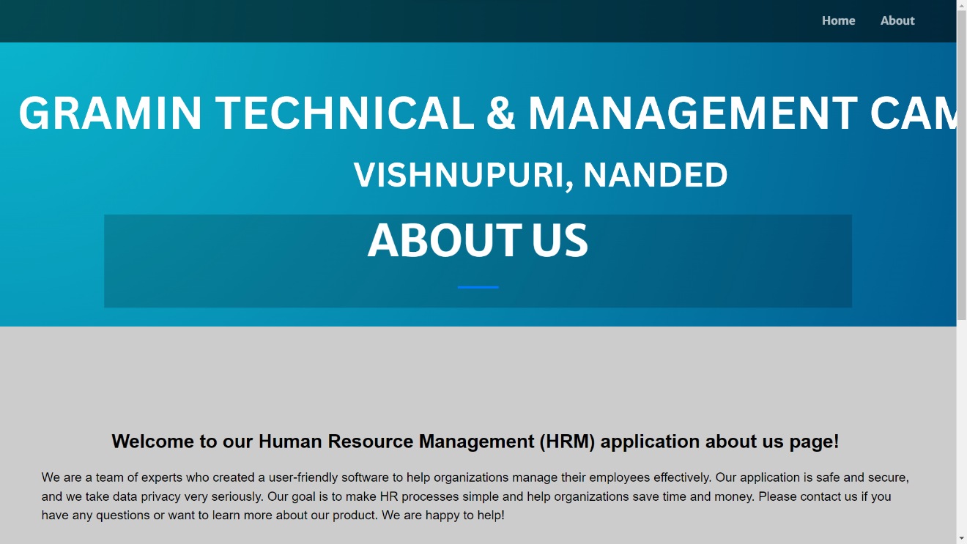About Us Section

**5.3.1.2 Admin Side**

Login

Admin Dashboard

Application List

Apply Application From Admin Side

Manage Vacancies

Edit Vacancy

Add New Vacancy

Edit Status Of Form

**5.3.2 Manage Employee Section**

**5.3.2.1 Admin Side**

Employees Management Dashboard

All Employee’s Overview

Add New Employee

Edit and Add New Position

Add/Edit Department

Store and Add Employee Files

All Campus Overview

All Employee Report Print

Generate Individual Report

Generate Retirement List

**Chapter 6**

**APPLICATIONS**

* **Employee data management**: HRIS allows organizations to store and manage employee data, including personal information, employment history, training and development, performance evaluations, and compensation data.
* **Recruitment and applicant tracking**: HRIS can streamline the recruitment process by automating job postings, resume tracking, and candidate screening.
* **Performance management**: HRIS can track employee performance and provide tools for setting goals, tracking progress, and providing feedback.
* **Time and attendance tracking**: HRIS can track employee time and attendance, including leave requests, overtime, and time off requests.
* **Payroll processing**: HRIS can automate payroll processing, including calculating taxes and deductions, generating paychecks, and providing employee pay stubs.
* **Benefits administration**: HRIS can manage employee benefits, including enrollment, eligibility, and plan details.
* **Compliance and reporting**: HRIS can assist with compliance and reporting requirements, including equal employment opportunity (EEO) reporting, Occupational Safety and Health Administration (OSHA) reporting, and employee data privacy and security.

**Chapter 7**

**FUTURE SCOPE**

The future scope of Human Resources Information System (HRIS) is broad and evolving. Some of the potential future developments and trends in HRIS include:

* **Artificial Intelligence (AI) integration**: AI can be integrated into HRIS to automate routine HR tasks and provide intelligent insights, such as identifying employee skill gaps or predicting employee turnover.
* **Mobile compatibility**: HRIS will continue to become more mobile-friendly, allowing employees and managers to access HR data and perform HR tasks on the go.
* **Employee self-service**: Employee self-service will become more prevalent in HRIS, allowing employees to update their personal information, request time off, and view their benefits and pay information.
* **Analytics and reporting**: HRIS will provide more robust reporting and analytics capabilities, allowing HR professionals to analyze data and make informed decisions about HR strategy and workforce management.
* **Social media integration**: HRIS will integrate with social media to enhance recruitment efforts and improve employer branding.
* **Virtual and augmented reality**: HRIS may integrate virtual and augmented reality technology for employee training and development, providing an immersive learning experience.
* **Blockchain integration**: HRIS may integrate blockchain technology to improve data security and privacy and enable more efficient and transparent employee record keeping.

Overall, the future of HRIS will continue to focus on automation, efficiency, and innovation to improve HR processes and enhance the employee experience.

**Chapter 8**

**STEPS TO INSTALL PROJECT**

To run the HRIS Human Resource Information System, you need to have a virtual server installed on your computer. We recommend using XAMPP for this purpose. The source code for the system is available for free download, but we advise that you use it for educational purposes only.

Once you have XAMPP running, follow these steps:

1. Extract the downloaded file.

2. Copy the main project folder.

3. Paste the folder in the 'htdocs' directory of XAMPP.

4. Next, you need to connect to the database:

Open your web browser and go to the URL "http://localhost/phpmyadmin/".

5. Click on the 'databases' tab.

6. Create a database named "recruitment_db" & "hrm" and click on the 'import' tab.

7. Click on the 'browse' button and select the "hrm.sql" file located in the 'Project' folder. Next, Click on the 'browse' button and select the "recruitment_db.sql" file located in the 'Project' folder.

8. Click on the 'Go' button.

9. Once the database is created, you can now run the system:

10. Open your web browser and go to the URL "http://localhost/<folder_name>".

11. To access the system as an admin, use the following credentials:

**Chapter 9  
CONCLUSION**

* In conclusion, a Human Resources Information System (HRIS) is an essential tool for managing employee data and automating HR processes. It provides significant benefits to organizations, including improving data accuracy and security, reducing manual tasks, and enhancing overall efficiency and productivity.
* A comprehensive feasibility study is crucial before implementing an HRIS to determine its technical, economic, legal, operational, schedule-wise, and cultural feasibility.
* The current trends in HRIS development include AI integration, mobile compatibility, employee self-service, analytics and reporting, social media integration, virtual and augmented reality, and blockchain integration.
* Overall, HRIS will continue to evolve, with a focus on automation, efficiency, and innovation to improve HR processes and enhance the employee experience. Organizations that implement HRIS can gain a competitive advantage by improving HR effectiveness and making data-driven decisions to manage their workforce more strategically.

**Chapter 9**

**REFERENCE**

* Bondarouk, T., & Ruël, H. J. (2009). Electronic human resource management: challenges in the digital era. The International Journal of Human Resource Management, 20(3), 505-514.
* Kavanagh, M. J., Thite, M., & Johnson, R. D. (2018). Human resource information systems: Basics, applications, and future directions. Sage Publications.
* Lengnick-Hall, M. L., & Moritz, S. (2003). The impact of e-HR on the human resource management function. Journal of Labor Research, 24(3), 365-379.
* Nadler, D. A., & Tushman, M. L. (1999). The organization of the future: Strategic imperatives and core competencies for the 21st century. Organizational Dynamics, 28(1), 45-60.
* Raghuram, A., & Arvey, R. D. (2019). Strategic human resource management and big data. Journal of Business Research, 98, 365-380.
* Sipior, J. C., & Ward, B. T. (2010). The role of information systems in human resource management. Information Systems Management, 27(2), 92-103.
* Thite, M., Kavanagh, M. J., & Johnson, R. D. (2012). Human resource information systems: Origins, applications, and research directions. Human Resource Management Review, 22(2), 88-100.
* Torrington, D., Hall, L., & Taylor, S. (2017). Human resource management. Pearson.
* Wright, P. M., Dunford, B. B., & Snell, S. A. (2001). Human resources and the resource-based view of the firm. Journal of Management, 27(6), 701-721.
* Yin, R. K. (2018). Case study research and applications: Design and methods. Sage publications.